**Rover - a robot for active response to shooters**

Project Rover was created in response to a growing number of shooting incidents in the US.

There were over 600 shooting incidents in 2022, resulting in over 400 deaths and over 2,000 injuries.



<https://www.ksat.com/news/local/2022/05/25/remembering-the-victims-of-the-uvalde-elementary-school-shooting/>

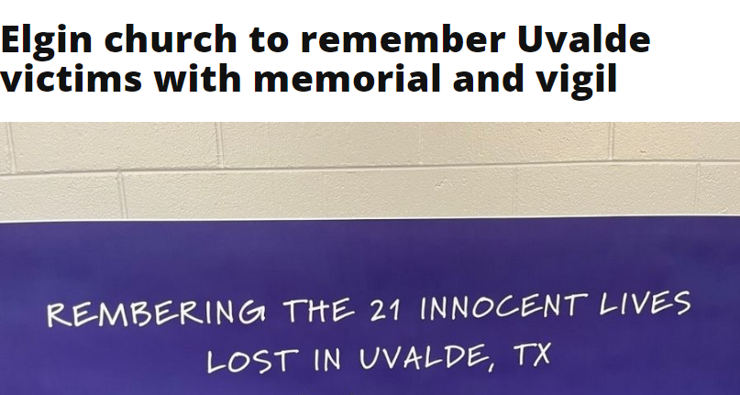

<https://www.dailyherald.com/submitted/20220526/elgin-church-to-remember-uvalde-victims-with-memorial-and-vigil>

These incidents have a devastating impact on communities and they have led to a growing demand for new and innovative solutions to prevent and respond to active shooters.

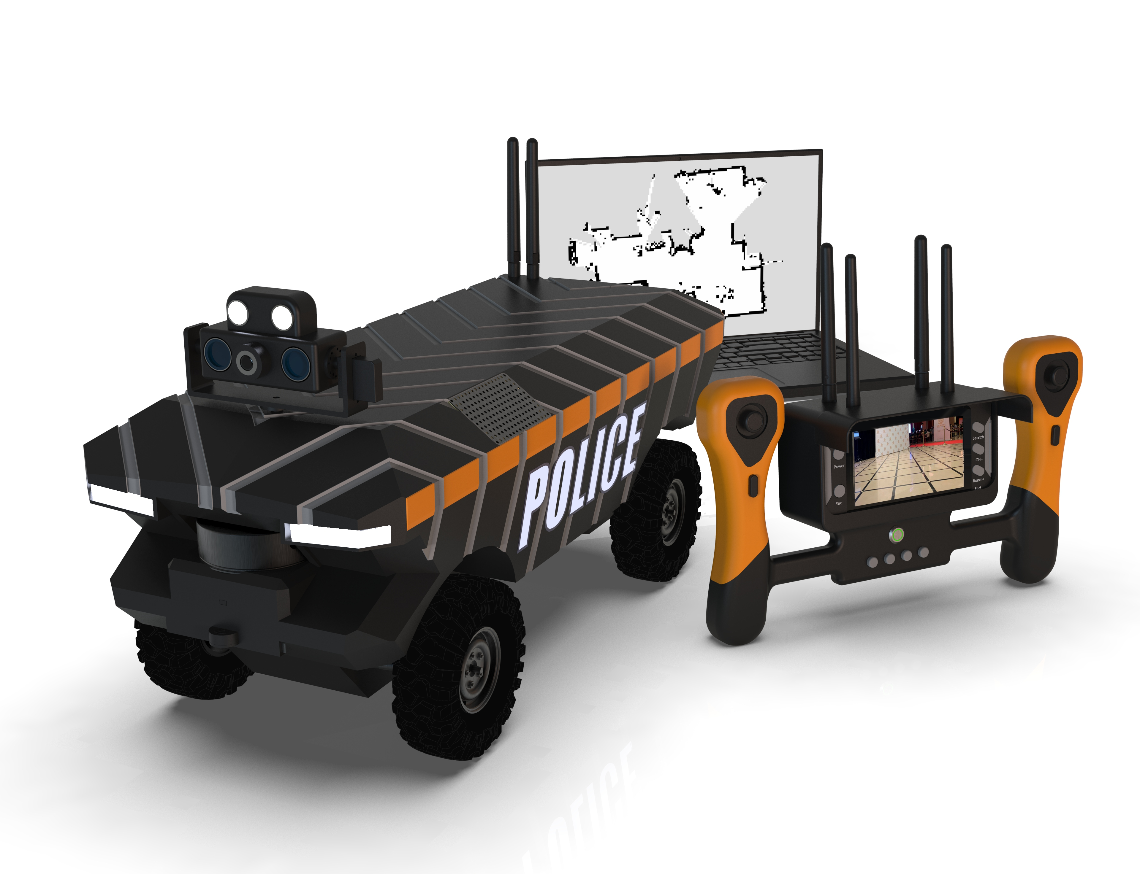

Robots offer a number of advantages over traditional shooter response methods. They can penetrate dangerous areas without endangering people's lives. They can be equipped with a variety of sensors and tools to help law enforcement officers assess the situation and respond appropriately. And they can be used to provide medical assistance to victims

Project Rover is committed to providing free robots to law enforcement, schools and hospitals. We believe that everyone has the right to feel safe in their communities and we are committed to doing our part to make this a reality.

If you would like to learn more about Project Rover or apply for a robot, please visit our website at **www.roverrobot.org**

Rover is a large steel chassis with the size Length: 435mm/17.1in, Width: 226mm/8.9in, wheelbase: 313mm/12.3in and 120mm rubber tires.

A protected body with electronic components and a powerful engine inside is installed on the chassis.

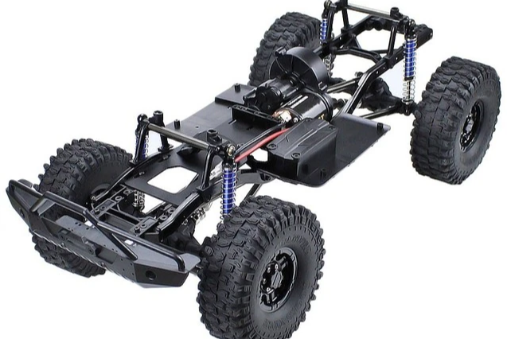

The device has a built-in Lidar - for compiling a 2D map of the room.

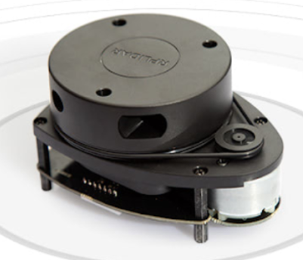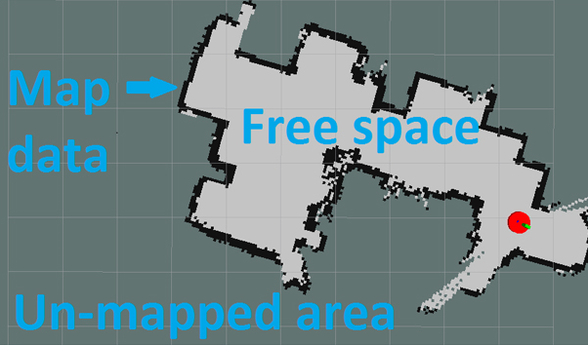

This data is transmitted wirelessly on a 2.4 GHz frequency to the laptop of the law enforcement team so that they can securely obtain information about the premises and possible obstacles in it before they personally enter the premises.

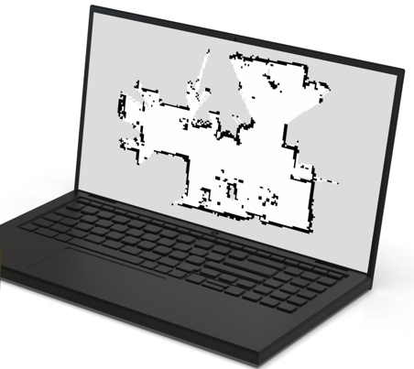

This robot is equipped with a two-way audio transmission system - in order to be able to use this robot as a secure communication line at a time when the frequencies of mobile and other communications are jammed.

In addition, this function can be useful if someone hid from the shooter and he does not have the ability to call or does not have a mobile phone.

Thus, two-way communication with law enforcement agencies can be used. Also, this function can be useful for people search or other sound notification - as it uses 2 speakers with a power of 2 watts.

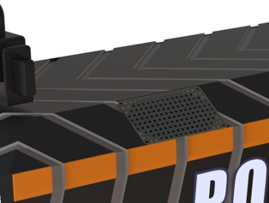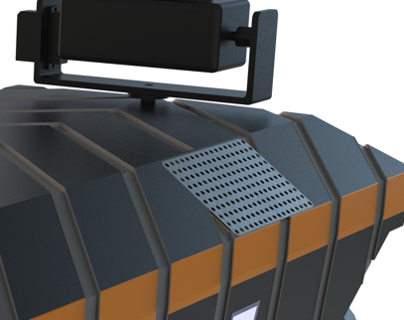

The system is equipped with an image stabilizer with a PTZ camera with night vision - this allows you to get a high-quality image even when the car is moving very fast or is tilted.

In addition, the camera is equipped with additional lights. The camera has the ability to rotate 360 degrees, as well as tilt up and down.

This also allows a better view of the area before the rapid response team enters the premises.

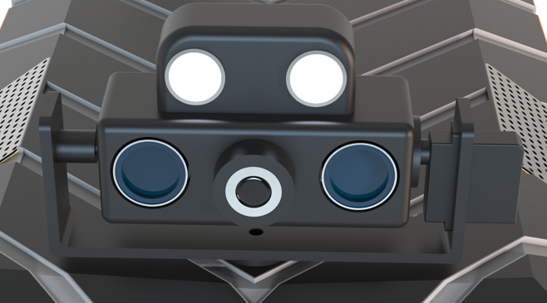

Rover is equipped with a powerful 2 watt video and digital signal transmitter with circular antennas! This allows you to transmit a signal with a range of 500 to 1000 meters with line of sight.

This power can be adjusted to 0.5 watts, 1 watt and 2 watts - so as not to violate the laws of the country in which the device is used.

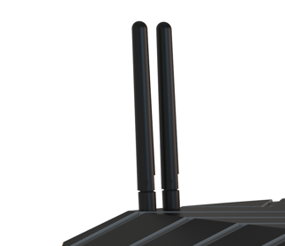

In addition to the main lights, Rover is equipped with two lights with IR illumination - this allows the operator to get a clear image even in complete darkness, and without the risk of detecting the robot by the shooter.

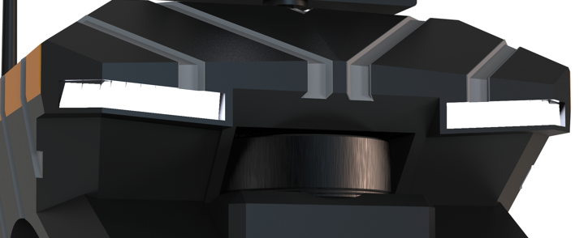

The autonomy of the robot can reach up to 4 hours of continuous operation when all functions are turned on. When using only the reconnaissance function, without mapping, this autonomy can be up to 8 hours of continuous operation.



The robot is controlled by a wireless remote control, which has two control joysticks, as well as buttons to control each mode.

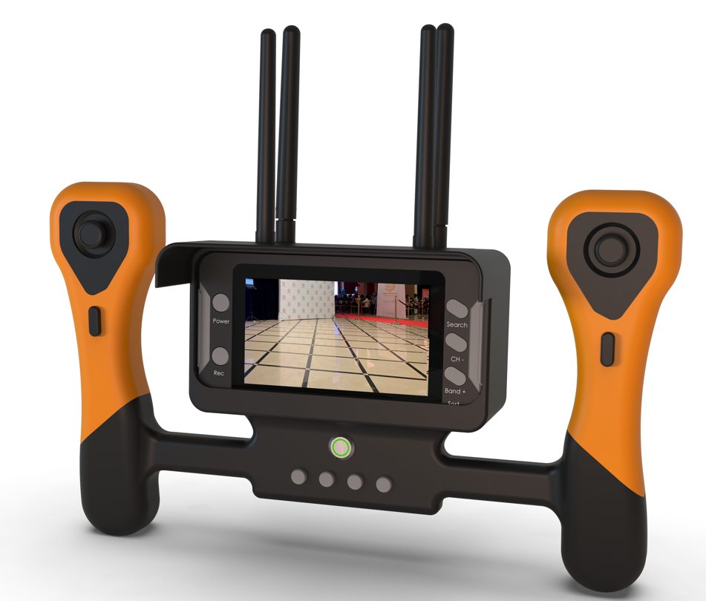

The left joystick is responsible for moving the robot, the right joystick is responsible for panning and tilting the PTZ camera.

On the main display, you can turn on the recording of what is happening, the recorded video is saved to the sd card. It is also possible to switch between the frequencies of other cameras, if they are in this network.

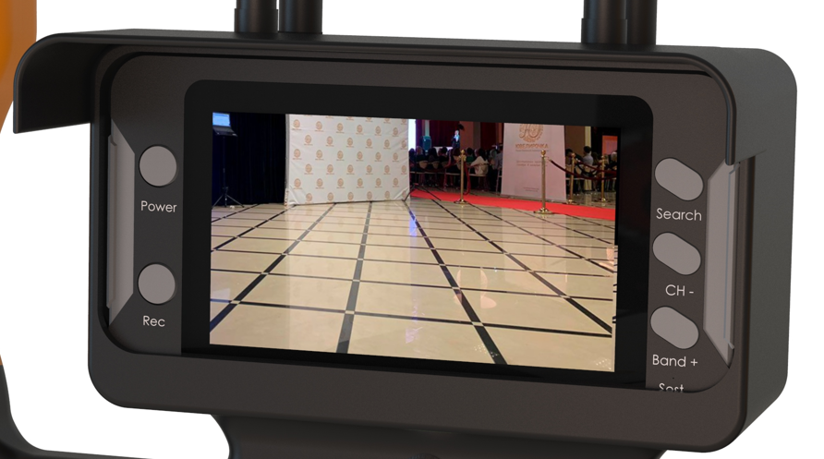

There are buttons for turning on the main light on the camera and hidden IR light on the car, turning on the lidar, turning on two-way audio, as well as additional modes that are available as an option.

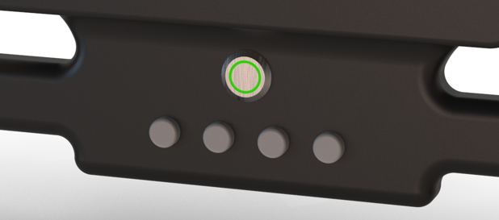

Optional modes and additional modifications:

- It can display the building autonomously and record RF data with a spectrum analyzer. To do this, the device is modified with a receiver on top and integrated with LIDAR mapping. https://ibwave.com/ibwave-mobile-survey-public-safety/

- The device can be modified with a special basket - when something needs to be transported or picked up. For example, bring medicines or food or something else.

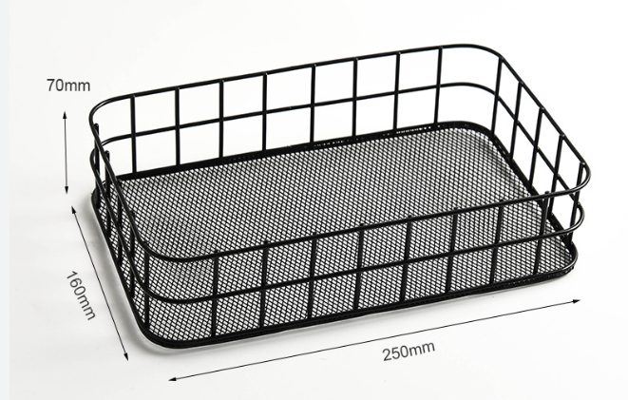

- The device can be modified with a special mechanism to be able to climb stairs. This function can be useful when the robot needs to climb to the second or subsequent floors.

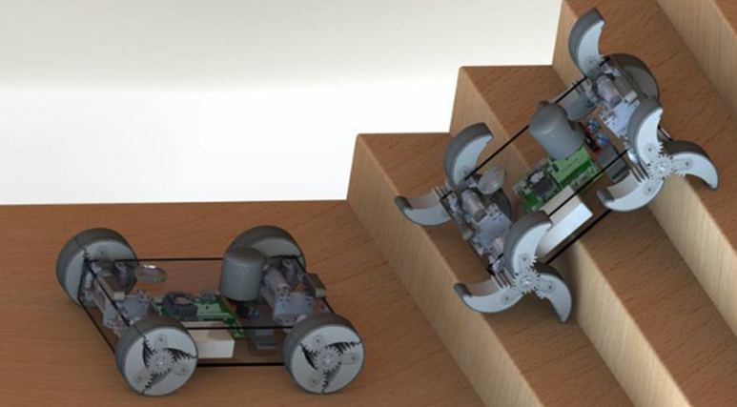

- The device can be modified with a thermal imager to detect shooters if they hide and are not in the field of view of the main camera.

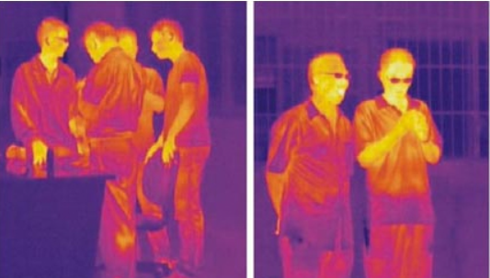

- The device can be modified with a loud ultrasonic siren to briefly incapacitate the shooter while the rapid response team enters the building or removes the hostages.

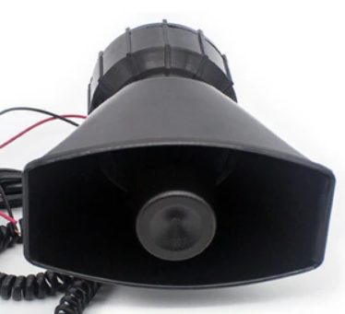

- In addition, there are many additional features that can be developed for each specific case or the request of law enforcement.

**Follow our updates:**

**Official website of the project**

https://www.roverrobot.org/

**The official website of the project on Linkedin**

https://www.linkedin.com/company/project-rover-inc/about/

**Engineering Team CTO**

https://www.linkedin.com/in/oleg-gridin-74563a226/

**Development team:**

<https://gec-engineering.tech/about-us/>

About global communications services

Global Communication Services is a leading provider of communications and security solutions. We are committed to helping our clients protect their people, property and information. We offer a wide range of solutions, including:

Security systems

Communication systems

Disaster Recovery Solutions

IT solutions

And more

We strive to provide our clients with the best possible solutions and strive to help them achieve their goals.